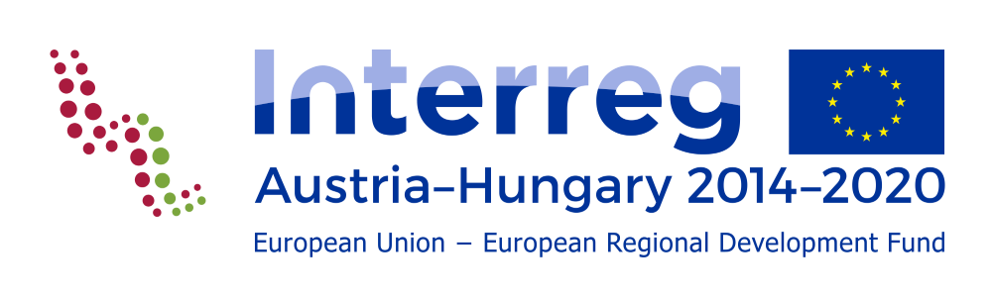

Periodic staff Report
for staff working in the project full time or part time with fixed %
Annex to Eligibility Handbook

Version 1.0/Annex to Eligibility Handbook
General information
Project number:
Project acronym:
Partner no:
Institution:

Personal and contractual information
Name of employee:
Main function:
Working full-time in the project:
(Ref. to 5.1.3.2.a point of the Eligibility Handbook)
Working part-time in the project according to a fixed % of time per month  (Ref. to 5.1.3.2.b.a point of the Eligibility Handbook)  (Please also specify the planned % per month as in the employment document and/or in the official assignment to the project) |  |  | (__ %)
Involved in other projects funded by EU or national subsidies: |  | YES NO
(If yes please specify the project(s) name, the funding programme(s) and the % of time allocated to such project(s))

Report of the period
Reporting period No.:
From: |  |  |  |  | dd.mm.yyyy
To: |  |  |  |  | dd.mm.yyyy
Description of activities carried out in the period under the relevant work package(s)
(at least 1000 characters)
Contribution to deliverables/outputs listed in the application form
(at least 500 characters)
Specification of missions occurred in the period:
Destination |  | From  (dd.mm.yyyy) | To  (dd.mm.yyyy) | Reason for mission

Date: |  |  | Signature of the employee
Date: |  |  | Name of the supervisor
 |  |  | Signature of the supervisor

